This file contains screenshots of the breakpoint debugging process and an explanation of how the error is affecting my code and how I can fix it using this debugging method.

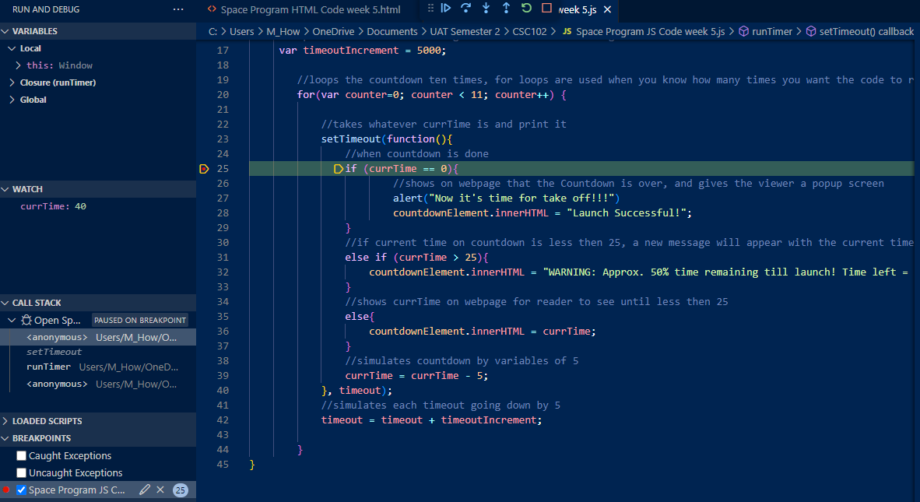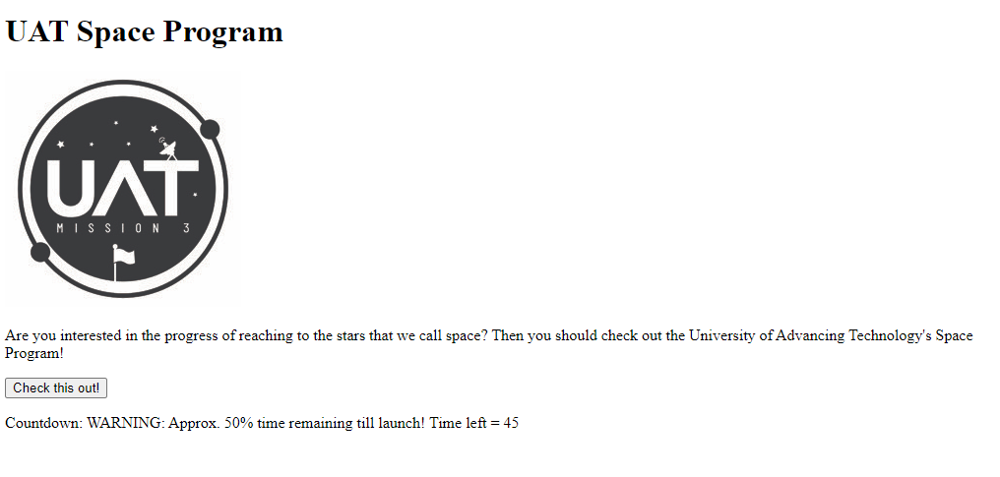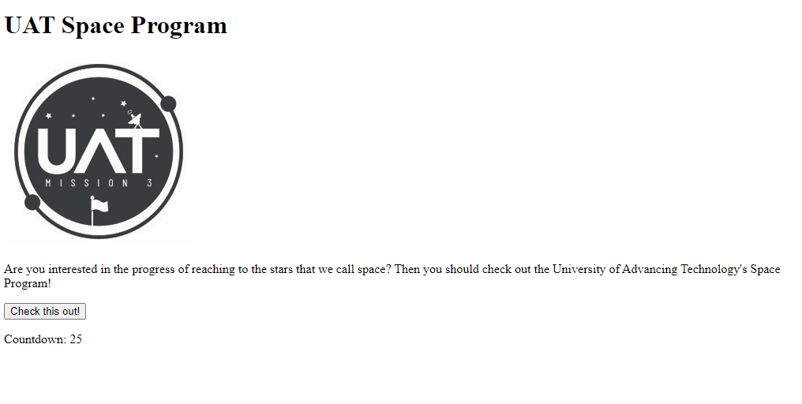

The error in this example is line 31: else if(currTime > 25). What this line does (without the error) is that once the countdown reaches 25 seconds or less, it’ll perform the line of code afterwards showing the viewer of the website a text block saying its reached 50%, although with the error it takes that and reverses it, making that text block appear in the first half of the countdown starting at 50, and then disappearing at the original starting point of 25. Using the debugging method, I placed the breakpoint a few lines above the error line, and then started debugging. I ran through the code watching the currTime variable go down, and realized the text block was appearing at the wrong time, giving me insight the error was indeed the “>” which was supposed to be “<”.